Ideation phase

# Brainstorm & Idea prioritization Template

|  |  |
| --- | --- |
| Date | 22 June 2025 |
| Team ID | LTVIP2025TMID50687 |
| Project Name | visualizing housing market trends: an analysis of sale prices and features using tableau |
| Maximum Marks | 4 Marks |

Brainstorm & Idea Prioritization Template:

Brainstorming provides a free and open environment that encourages

everyone within a team to participate in the creative thinking process that leads to problem solving Prioritizing volume over value out-of-the-box ideas are welcome and build up on and all participants are encouraged to collaborate helping each other develop a rich amount of creative solutions.

Step-1: Team Gathering Collaboration and Select the Problem Statement

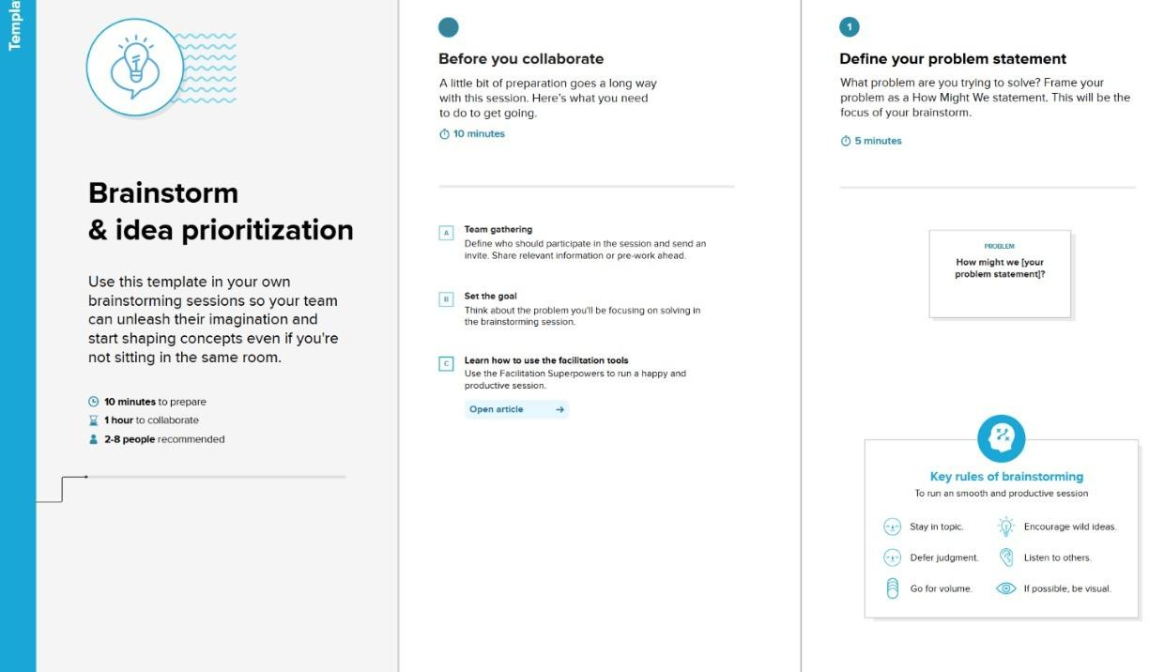

# Step-2: Brainstorm, Idea Listing and Grouping

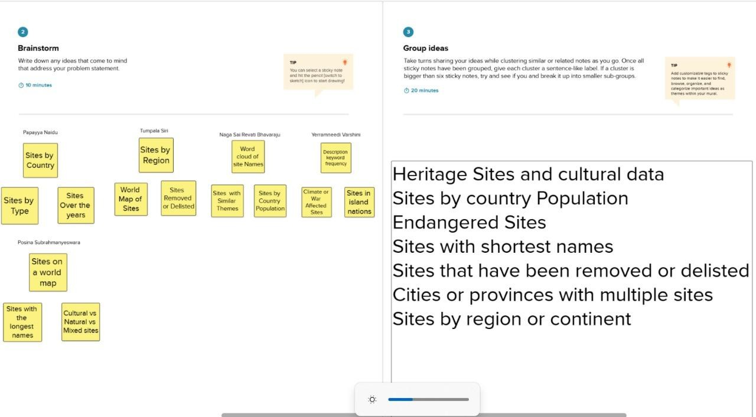

Step-3: Idea Prioritization

